**DataBase**

Исходный код проекта:

<https://github.com/verkhoumov/AndroidLabs/tree/master/DataBase>

Скриншоты экрана:

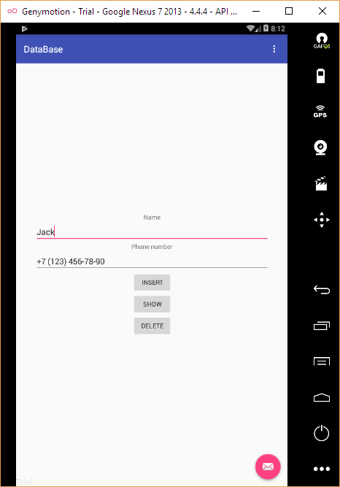

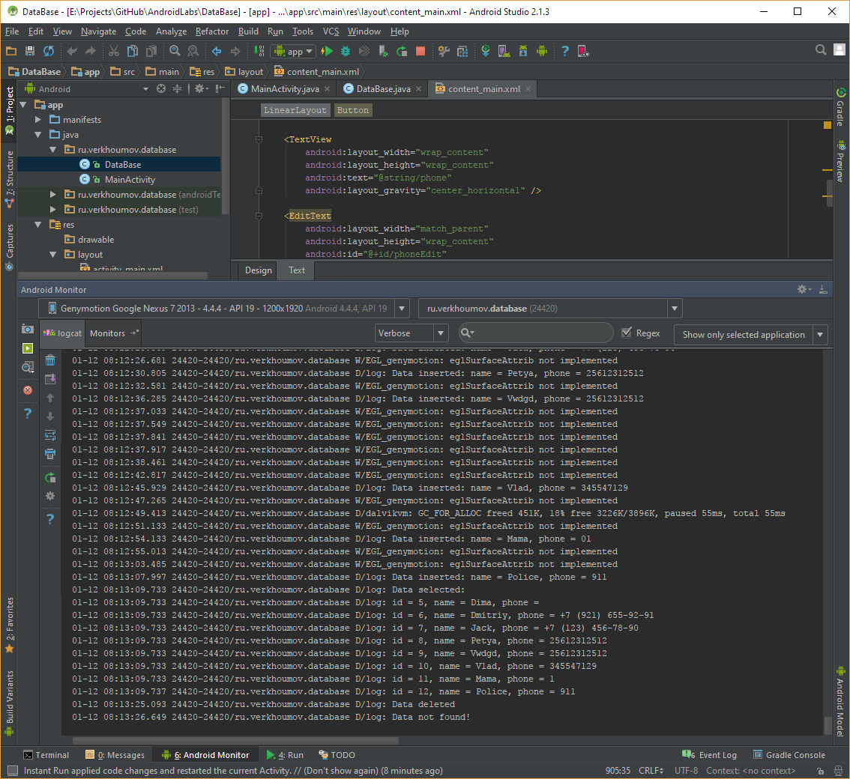

Исходный код.

MainActivity.java:

1. **package** ru.verkhoumov.database;
3. **import** android.content.ContentValues;
4. **import** android.database.Cursor;
5. **import** android.database.sqlite.SQLiteDatabase;
6. **import** android.os.Bundle;
7. **import** android.support.design.widget.FloatingActionButton;
8. **import** android.support.design.widget.Snackbar;
9. **import** android.support.v7.app.AppCompatActivity;
10. **import** android.support.v7.widget.Toolbar;
11. **import** android.util.Log;
12. **import** android.view.View;
13. **import** android.view.Menu;
14. **import** android.view.MenuItem;
15. **import** android.widget.Button;
16. **import** android.widget.EditText;
18. **public** **class** MainActivity **extends** AppCompatActivity {
19. EditText name, phone;
20. Button insert, show, delete;
21. DataBase dataBase;
23. @Override
24. **protected** **void** onCreate(Bundle savedInstanceState) {
25. **super**.onCreate(savedInstanceState);
26. setContentView(R.layout.activity_main);
27. Toolbar toolbar = (Toolbar) findViewById(R.id.toolbar);
28. setSupportActionBar(toolbar);
30. *// Поля ввода данных и кнопки.*
31. name = (EditText) findViewById(R.id.nameEdit);
32. phone = (EditText) findViewById(R.id.phoneEdit);
33. insert = (Button) findViewById(R.id.insertBtn);
34. show = (Button) findViewById(R.id.showBtn);
35. delete = (Button) findViewById(R.id.deleteBtn);
37. *// База данных.*
38. dataBase = **new** DataBase(**this**);
39. **final** SQLiteDatabase sqLiteDatabase = dataBase.getWritableDatabase();
41. *// Обработчики кнопок.*
42. insert.setOnClickListener(**new** View.OnClickListener() {
43. @Override
44. **public** **void** onClick(View view) {
45. String _name = name.getText().toString();
46. String _phone = phone.getText().toString();
48. *// Добавляем новую запись в базу данных.*
49. ContentValues contentValues = **new** ContentValues();
50. contentValues.put("name", _name);
51. contentValues.put("phone", _phone);
52. sqLiteDatabase.insert("Contact", **null**, contentValues);
54. *// Логгируем событие.*
55. Log.d("log", "Data inserted: name = " + _name + ", phone = " + _phone);
56. }
57. });
59. show.setOnClickListener(**new** View.OnClickListener() {
60. @Override
61. **public** **void** onClick(View view) {
62. Cursor cursor = sqLiteDatabase.query("Contact", **null**, **null**, **null**, **null**, **null**, **null**);
64. **if** (cursor.moveToFirst()) {
65. Log.d("log", "Data selected:");
67. **do** {
68. **int** _id = cursor.getInt(cursor.getColumnIndex("id"));
69. String _name = cursor.getString(cursor.getColumnIndex("name"));
70. String _phone = cursor.getString(cursor.getColumnIndex("phone"));
72. Log.d("log", "id = " + _id + ", name = " + _name + ", phone = " + _phone);
73. } **while** (cursor.moveToNext());
74. } **else** {
75. Log.d("log", "Data not found!");
76. }
77. }
78. });
80. delete.setOnClickListener(**new** View.OnClickListener() {
81. @Override
82. **public** **void** onClick(View view) {
83. sqLiteDatabase.delete("Contact", **null**, **null**);
85. Log.d("log", "Data deleted");
86. }
87. });
89. FloatingActionButton fab = (FloatingActionButton) findViewById(R.id.fab);
90. fab.setOnClickListener(**new** View.OnClickListener() {
91. @Override
92. **public** **void** onClick(View view) {
93. Snackbar.make(view, "Replace with your own action", Snackbar.LENGTH_LONG)
94. .setAction("Action", **null**).show();
95. }
96. });
97. }
99. @Override
100. **public** **boolean** onCreateOptionsMenu(Menu menu) {
101. *// Inflate the menu; this adds items to the action bar if it is present.*
102. getMenuInflater().inflate(R.menu.menu_main, menu);
103. **return** **true**;
104. }
106. @Override
107. **public** **boolean** onOptionsItemSelected(MenuItem item) {
108. *// Handle action bar item clicks here. The action bar will*
109. *// automatically handle clicks on the Home/Up button, so long*
110. *// as you specify a parent activity in AndroidManifest.xml.*
111. **int** id = item.getItemId();
113. *//noinspection SimplifiableIfStatement*
114. **if** (id == R.id.action_settings) {
115. **return** **true**;
116. }
118. **return** **super**.onOptionsItemSelected(item);
119. }
120. }

DataBase.java:

1. **package** ru.verkhoumov.database;
3. **import** android.content.Context;
4. **import** android.database.sqlite.SQLiteDatabase;
5. **import** android.database.sqlite.SQLiteOpenHelper;
7. **public** **class** DataBase **extends** SQLiteOpenHelper {
8. **public** DataBase (Context context) {
9. **super**(context, "db", **null**, 1);
10. }
12. @Override
13. **public** **void** onCreate(SQLiteDatabase sqLiteDatabase) {
14. sqLiteDatabase.execSQL("CREATE TABLE IF NOT EXISTS `Contact` (`id` INTEGER PRIMARY KEY AUTOINCREMENT, `name` TEXT, `phone` INTEGER);");
15. }
17. @Override
18. **public** **void** onUpgrade(SQLiteDatabase sqLiteDatabase, **int** i, **int** i1) {
20. }
21. }

content_main.xml:

1. **<?xml** version="1.0" encoding="utf-8"**?>**
2. **<LinearLayout** xmlns:android="http://schemas.android.com/apk/res/android"
3. xmlns:app="http://schemas.android.com/apk/res-auto"
4. xmlns:tools="http://schemas.android.com/tools"
5. android:layout_width="match_parent"
6. android:layout_height="match_parent"
7. android:paddingBottom="@dimen/activity_vertical_margin"
8. android:paddingLeft="@dimen/activity_horizontal_margin"
9. android:paddingRight="@dimen/activity_horizontal_margin"
10. android:paddingTop="@dimen/activity_vertical_margin"
11. app:layout_behavior="@string/appbar_scrolling_view_behavior"
12. tools:context="ru.verkhoumov.database.MainActivity"
13. tools:showIn="@layout/activity_main"
14. android:orientation="vertical"
15. android:gravity="center_vertical"**>**
17. **<TextView**
18. android:layout_width="wrap_content"
19. android:layout_height="wrap_content"
20. android:text="@string/name"
21. android:layout_gravity="center_horizontal" **/>**
23. **<EditText**
24. android:layout_width="match_parent"
25. android:layout_height="wrap_content"
26. android:id="@+id/nameEdit"
27. android:layout_gravity="center_horizontal"
28. android:inputType="text"
29. android:layout_marginStart="25dp"
30. android:layout_marginEnd="25dp" **/>**
32. **<TextView**
33. android:layout_width="wrap_content"
34. android:layout_height="wrap_content"
35. android:text="@string/phone"
36. android:layout_gravity="center_horizontal" **/>**
38. **<EditText**
39. android:layout_width="match_parent"
40. android:layout_height="wrap_content"
41. android:id="@+id/phoneEdit"
42. android:layout_gravity="center_horizontal"
43. android:inputType="phone"
44. android:layout_marginStart="25dp"
45. android:layout_marginEnd="25dp" **/>**
47. **<Button**
48. android:layout_width="wrap_content"
49. android:layout_height="wrap_content"
50. android:text="@string/insert"
51. android:id="@+id/insertBtn"
52. android:layout_gravity="center_horizontal" **/>**
54. **<Button**
55. android:layout_width="wrap_content"
56. android:layout_height="wrap_content"
57. android:text="@string/show"
58. android:id="@+id/showBtn"
59. android:layout_gravity="center_horizontal" **/>**
61. **<Button**
62. android:layout_width="wrap_content"
63. android:layout_height="wrap_content"
64. android:text="@string/delete"
65. android:id="@+id/deleteBtn"
66. android:layout_gravity="center_horizontal" **/>**
67. **</LinearLayout>**

strings.xml:

1. **<resources>**
2. **<string** name="app_name"**>**DataBase**</string>**
3. **<string** name="action_settings"**>**Settings**</string>**
4. **<string** name="insert"**>**INSERT**</string>**
5. **<string** name="show"**>**SHOW**</string>**
6. **<string** name="delete"**>**DELETE**</string>**
7. **<string** name="name"**>**Name**</string>**
8. **<string** name="phone"**>**Phone number**</string>**
9. **</resources>**